Transportation Request - Infinite Campus Parent Portal

* Login to [Parent Portal](https://chandleraz.infinitecampus.org/campus/portal/parents/chandler.jsp)
* From the home page, locate “Quick Links” (on the far right on a computer or at the very bottom of the app).
* Click on “Transportation Request” under the Quick Links section.

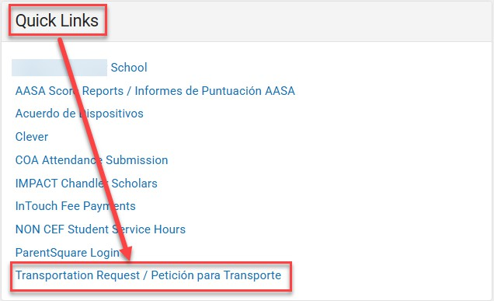

* Select English or Spanish.

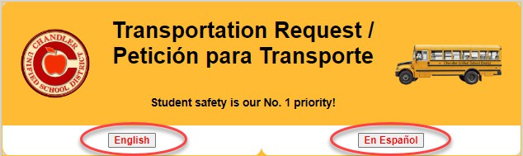

* Read through the Transportation information, click the box to acknowledge the information, and click “Click here to proceed to the Transportation Request”.

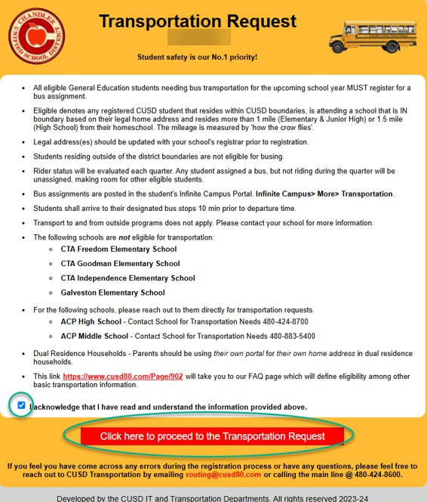

* You will be taken to a screen similar to the one shown below that will list your student(s), their eligibility status, an option to submit a request, an option to request an exception, or responses if it’s already been submitted.

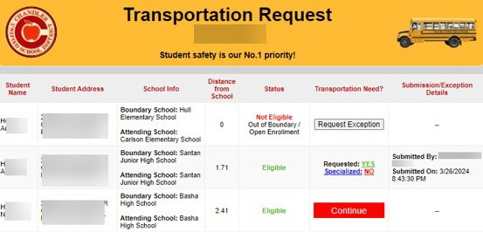

* If a student **is eligible**, click “continue”



* 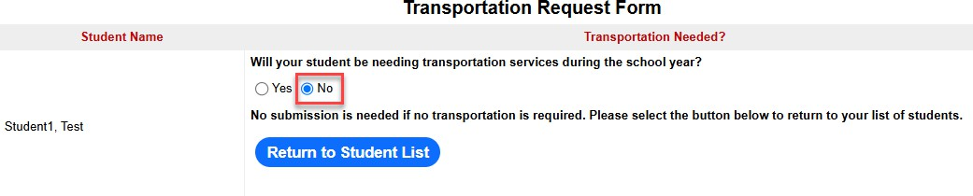We only require a submission if a family needs transportation. If you select “no”, you will be given information saying that no submission is required.
* If you want to request transportation, click “yes” and complete the questionnaire accordingly.

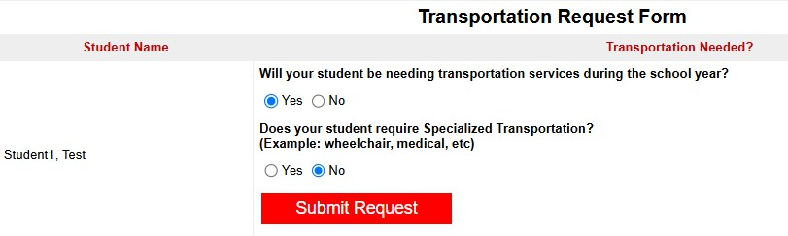

* If a student is not eligible, it will display the reason why they aren’t eligible as well as provide a link for “Request Exception” if you’d like to request an exception for transportation. *Reception requests are only allowed if your household is within CUSD boundaries. Outside of CUSD boundaries will not allow for an exception request*

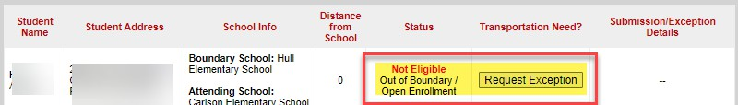

* After selecting “Request Exception”, you can enter your exception reason and submit your request.

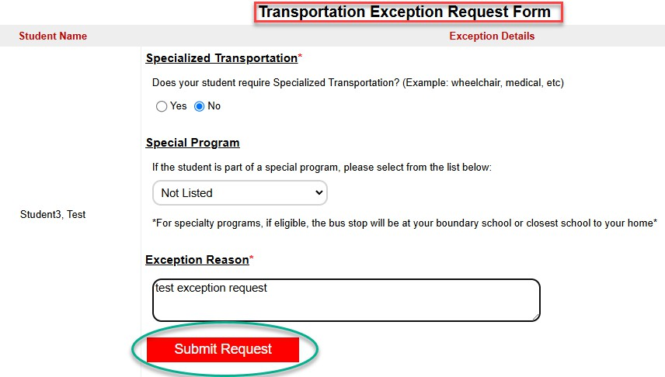

* After submitting a transportation or exception request, you can view the confirmation details including the date and parent who submitted the request.

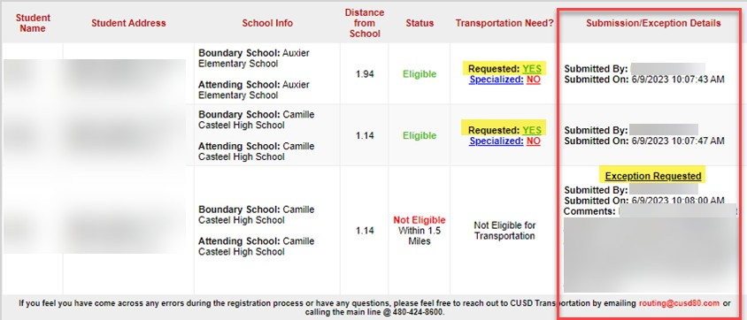

Once submitted, you will not be able to change your answer* Exception Request Reasons cannot be changed once submitted.

*If your household address changes during the school year, the tab will automatically re-open for you to go in and make a new selection for the new household address.

If you want to change your selection, you’ll need to contact the Transportation department at 480-424- 8600.